BRAIN-TARGETED TEACHING
LEARNING UNIT

Name: Elizabeth Harris Dates: March 2012- May 2012
Unit Title: Improving attention skills in the classroom.
Grade Level: 4
Content Standard(s): Students will demonstrate the ability to attend in the classroom in order to meet grade level expectations and learning objectives.

Learning Unit Overview:

The objective of this learning unit is to teach a small group of 4th grade boys to:
- Identify on/off task behaviors
- Understand the impact paying attention has on learning and emotions
- Identify distractors that draw them off task
- Learn how to apply strategies to stay on task

Brain Target #1
Emotional Connection:
To develop a positive emotional learning climate rules and routines are established to create a sense of predictability. Learning activities are changed weekly to provide novelty, increase motivation, and hold students’ attention. Relaxation activities are used at the beginning of each group to attempt to settle the boys’ energy and promote a calm mood. To develop a sense of community the group reviews rules and group objectives, and members are encouraged to share experiences from their week related to group objectives.
Group leaders encourage positive group dynamics by providing positive feedback for respectful, productive, and attentive behavior; remaining calm when the energy level escalates; and by responding to inappropriate behavior with firm but sensitive reminders of rules and consequences.

Brain Target #2
Physical Environment:
Environmental elements are adapted to enhance the learning environment in the following ways:

Placing chairs in a semi-circle to promote discussion and foster group cohesion
Posters related to learning objectives are hung where the group can see them
Visual distractions and materials not related to group activities are eliminated
Relaxation music is played and a lavender scent is sprayed for a calming effect
Group rules are posted within sight of the group to set behavioral expectations

Brain Target #3
Concept Map

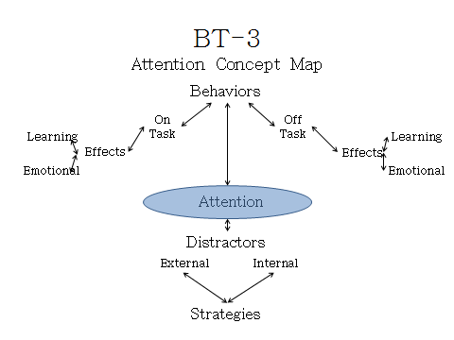
Learning Goals:
The learning goals of this unit are to have a small group of 4th grade boys:
Identify how attention is demonstrated by on and off task behaviors
Understand the effects paying attention, or not, has on learning and their emotions
Identify distractors that draw them off task
Learn and apply strategies for staying on task

Introductory Assessment of Prior Knowledge:
To assess the group’s knowledge about on and off task behavior they were asked to brain storm ideas of “what it looks like to be on task” and “what it looks like to be off task”. Their responses were written on the board in a T-chart.

Brain Target #4
Activities for Teaching Mastery of Declarative/Procedural Knowledge
To identify the effect paying attention has on learning and emotions the students are first asked to create a drawing or comic depicting a situation in which they have stayed on task successfully. On the other side of this paper they are asked to do the same thing for a situation they had difficulty staying on task. Next the students are to write feelings around their picture which they experienced during each situation. One objective is met with this activity when students note the differences in how they feel about themselves in these two different situations. The students are asked to present their work to the group at large for discussion. During the discussion students will share similarities and differences between each other’s experiences; offer ideas about why they think paying attention is important in each situation; share what they learned when they paid attention and the consequences they faced when they did not pay attention.

Brain Target #5
Activities for Extension and Application of Knowledge
To help students learn to identify distractors in their environment they will role play scenarios in which one student tries to attend to task amidst distraction. To help students learn strategies for staying on task they group will offer suggestions after each group completes their role play. This activity will proceed as follows:

Students break up into to three small groups
Each group randomly chooses a situation that depicts an activity requiring one student to pay attention
Students assign the following roles:
One person who attempts to stay on task
One person who tries to teach or direct him
Two people who act as distractors.
The group makes up the lines, distractors, and how the student attending reacts
Each group presents its scenario to the group at large
Group discussions about each scenario focus on identifying the distractors
During discussion group members generate strategies for staying on task

Brain Target #6
Evaluating Learning:
To evaluate students’ learning each student will complete a project to demonstrate their understanding of learning objectives. Students will be given a chose to create a comic or write a story depicting a scenario in which the main character is in a situation requiring their attention. A requirement will be to identify environmental distractors or potential distractors the main character encounters. Students will be asked to identify three strategies the main character applies to stay on task. The storyline will need to include how the character benefited, or what the main character learned by staying on task. A scoring rubric will used to assess each student’s project.

Other assessment options include:
Observations by group leader and self-report from members during group discussions
Pre- & Post Self-Assessment and Teacher Assessment
Written reflection by each student about their experience in the group
Individual conference with the group leaders about what they gained from participating

References
Hardiman, Mariale M. (2003). Connecting brain research with effective teaching. Lanham, Maryland: Rowman & Littlefield Publishers.
Rinne, L., Gregory, E., Yarmolinksaya J., & Hardiman M., (2011) Why arts integration improves long term retention of content. Mind, Brain and Education, 5(2), 89-96.
Willingham, Daniel T. (2011) Can Teachers increase Students’ Self-Control. American Educator, Summer 2011, 22-27.

